**Capstone Project: Best Neighborhood in Tokyo for Location of Ballet School**

Introduction

This is my capstone project for Coursera IBM Data Science Professional Certificate.

Fictional background for my project is as follows:

I was contacted by an owner of the ABC schools of ballet who operates three successful ballet schools in US. He is planning to open a new school in Tokyo, Japan, and asked me to find the best neighborhood in Tokyo for a location of his new school.

Data

The following datasets were used:

* Geographic data of the neighborhoods in Tokyo obtained as a csv file downloaded from https://www.aggdata.com/free/japan-postal-codes

* Data of the ballet schools in Tokyo obtained Foursquare

* Data of the venues in the neighborhoods in Tokyo obtained from Foursquare

Analysis

1. Locations of Ballet Schools in Tokyo

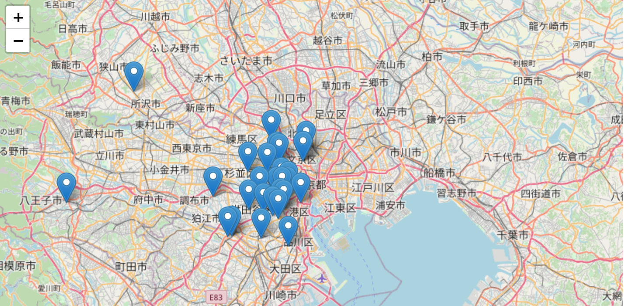

Most of the ballet schools in Tokyo are located in the Tokyo Metropolitan area. There is a competition among schools in this area especially against a new school. Therefore, the location for a new school will be better in the outskirt of the metropolitan area.

1. Neighborhoods in Tokyo

The neighborhoods in Tokyo were clustered and segmented according to the types of the venues in each neighborhood by using k-means.

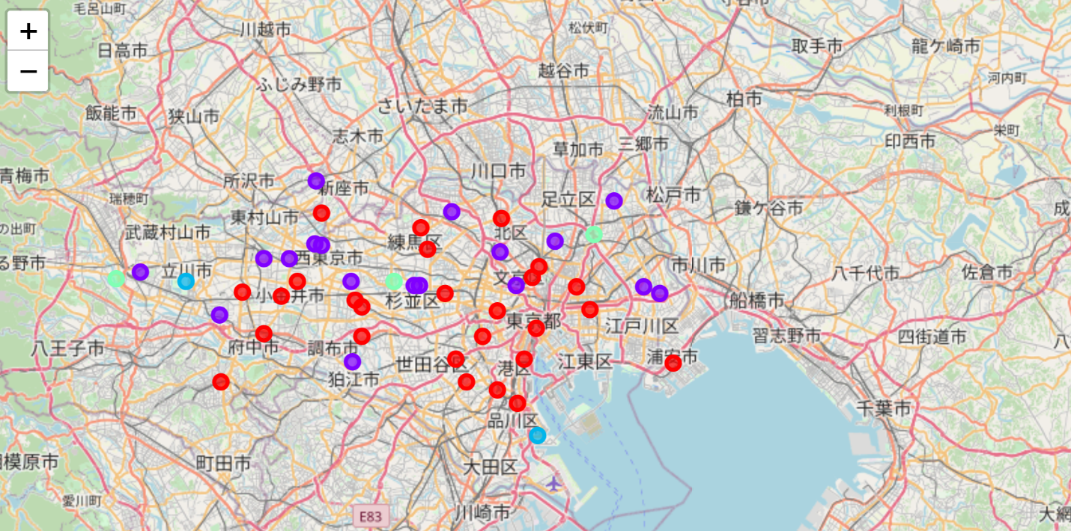

The common venues in the red neighborhoods are restaurants, cafes, and convenience stores. The common venues in the purple neighborhoods are convenience stores, parks, and restaurants. The common venues in the blue neighborhoods are parks and museums. The common venues in the green neighborhoods are parks and restaurants.

1. Comparison between Two Maps

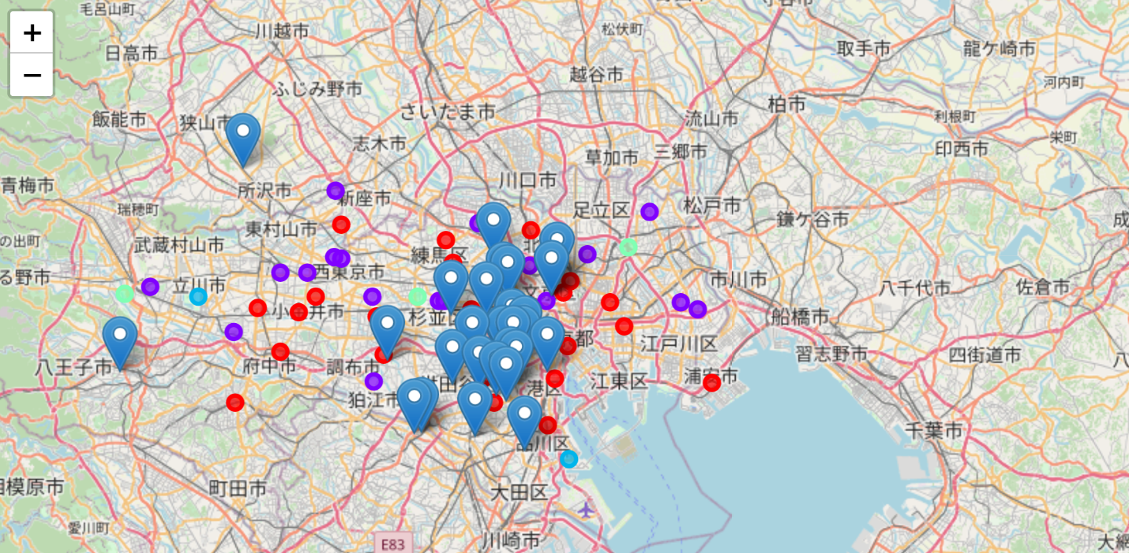

The most of the existing ballet schools are in the red neighborhoods.

Conclusion / Discussion

From the dataset we used, we can conclude the recommended locations of a new ballet school will be the red neighborhoods in the outskirt of the metropolitan area. The common venues in the red neighborhoods are restaurants, cafes, and convenience stores, where people gather the most so it makes sense to be best locations for a new school. In addition, we will be able to narrow our search by considering other factors such as real estate and accessibility.